1. Generate sine wave of frequency 1 KHz and peak value V peak =10V.Keep DC offset zero volt. Observe the waveform on CRO. Verify the frequency and voltage on CRO (Observe time/division on X-axis and volt/division on Y=axis).Change the frequency and voltage and verify.

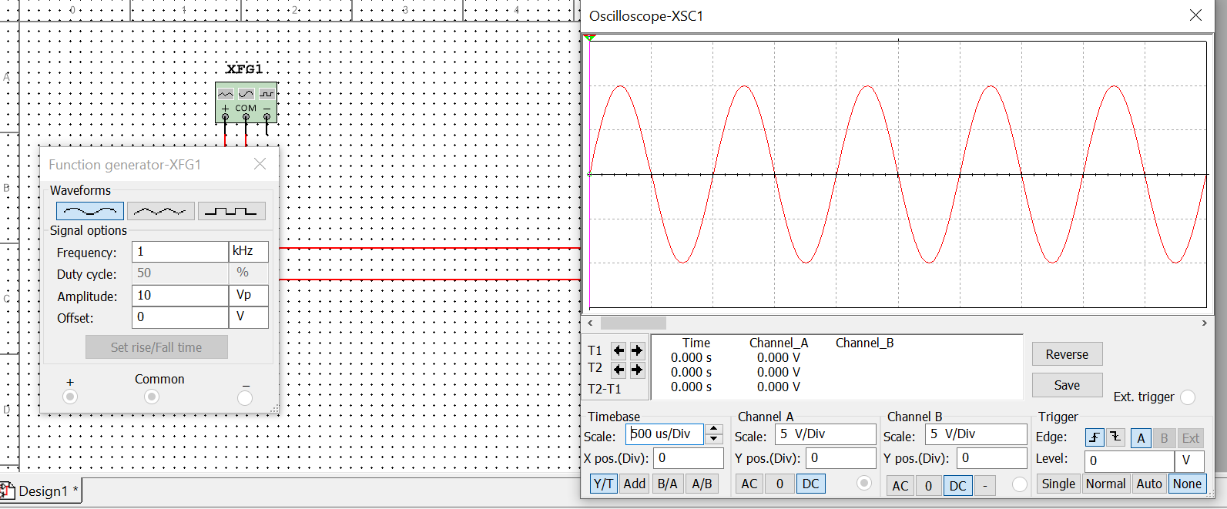

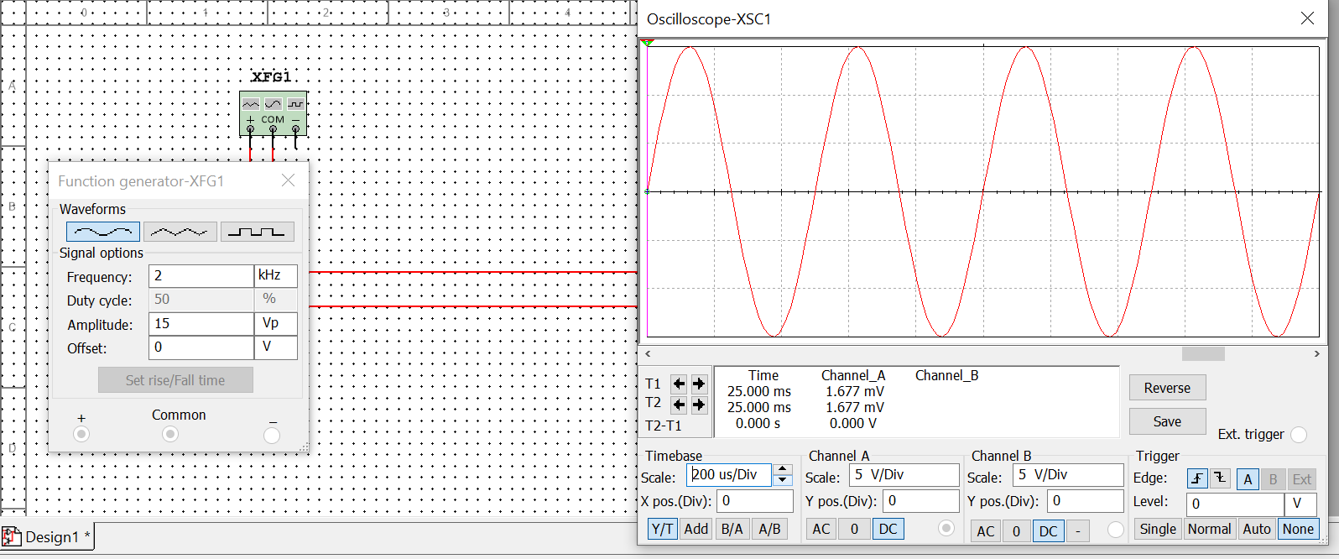

1. Generate Triangular wave of frequency 1 KHz and peak value V peak =10V.Keep DC offset zero volt. Observe the waveform on CRO. Verify the frequency and voltage on CRO (Observe time/division on X axis and volt/division on Y=axis.

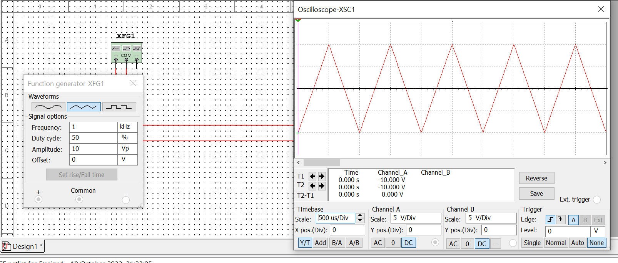

1. Generate square wave of frequency 1 KHz and peak value V peak =10V.Keep DC offset zero volt. Observe the waveform on CRO. Verify the frequency and voltage on CRO (Observe time/division on X axis and volt/division on Y=axis).Change the frequency and voltage and verify.

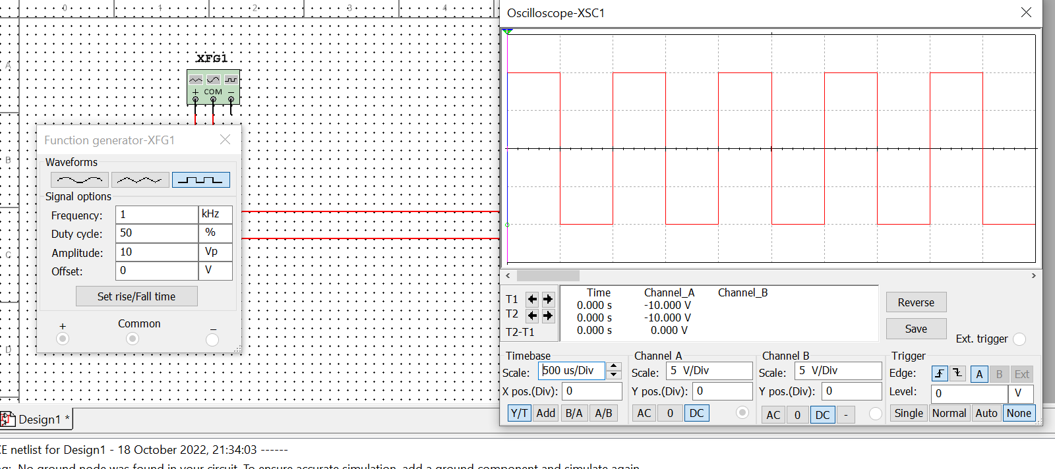

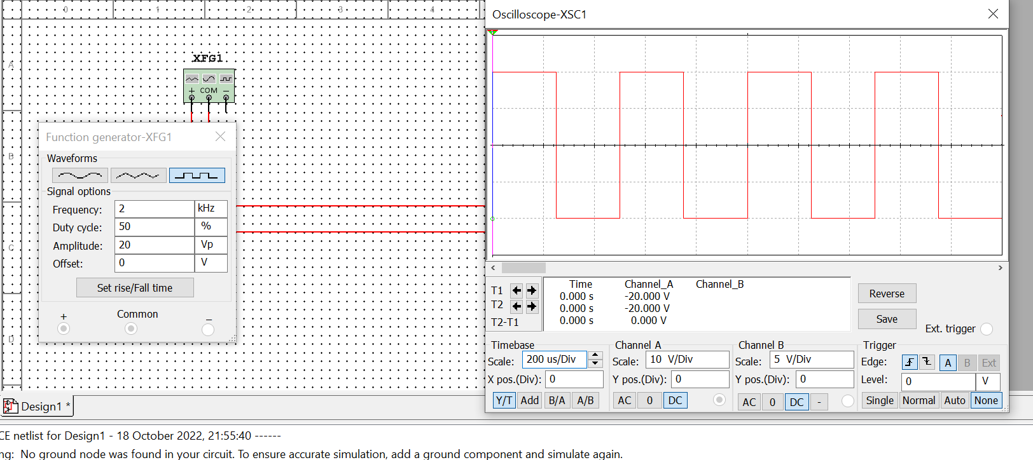

1. Repeat Problem-1 with following changes. Set DC offset to 1V.Observe the wave form on CRO. Notice the importance AC and DC switch on CRO. Write down your observation about the meaning of AC and DC switch mentioned on CRO.

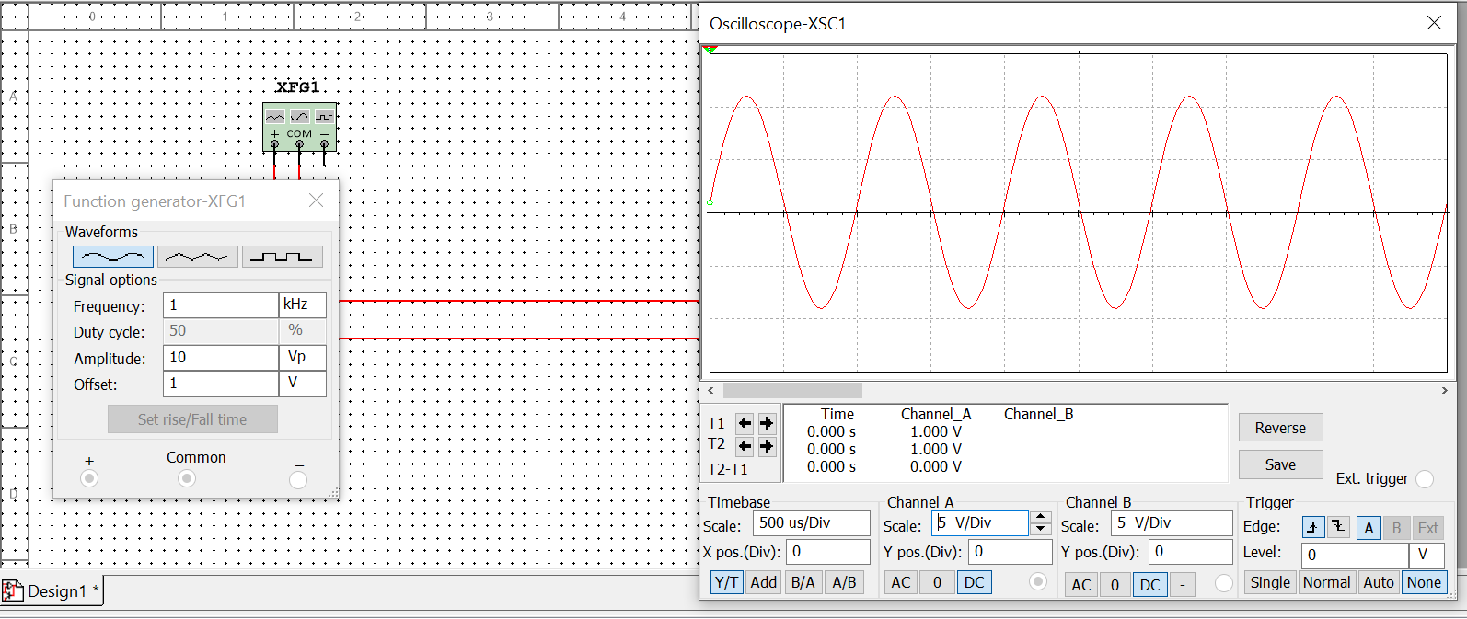

1. Connect AC power source to a resistive load. Assume value of AC power source 10Vrms and load resistor is 1KΩ.With the use of multimeter as a voltmeter, measure the voltage across load resistor. Also measure the current through load resistor using multimeter as an Ampere meter. Observe the output on CRO and write the peak value of voltage across

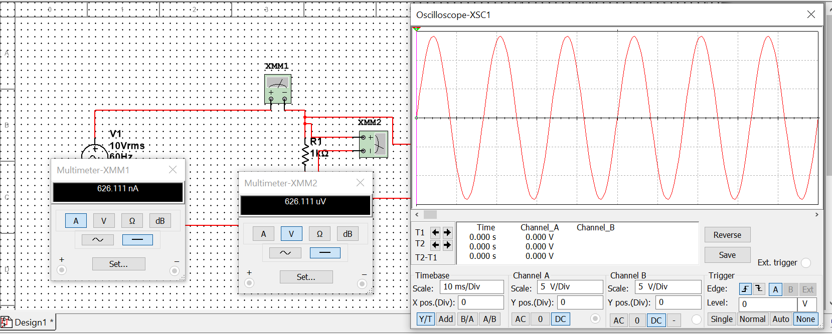

1. Connect DC power of 5V DC to a voltage divider network. Choose R1 value 100Ω and R2 value of 200Ω. Measure voltage across R2 and current through R2 using multimeter. Verify the result of simulation with theoretical approach.

V= R1I + R2I V= 100I + 200I V= (300) I

I= 5/300 I= 0.016 A

I = 16.667 mA

V2 = V (R2/R1+R2)

= 5\*(200/200+100)

= 5\*200/300

= 3.333 V

